Table of Contents

1 Table of Figures 1

2 Table of Tables 1

3 Table of Equations 1

1 Subsystem Five: Actuation Systems 2

1.1 Requirements and Functional Decomposition 2

1.2 Background and Prior Art 3

1.3 Approach and Execution 3

1.4 Results and Discussion 7

2 Bibliography 9

# Table of Figures

Figure 36: SS5 Breakdown 2

Figure 37: MG995 - High Speed Metal Gear Dual Ball Bearing Servo 4

Figure 38: 900-00008 - Continuous Rotation Servo 4

Figure 39: Test A Configuration 5

Figure 40: Test B Configuration 5

# Table of Tables

Table 10: PWM Configuration 6

Table 11: Motor PWM Requirements 6

# Table of Equations

No table of figures entries found.

# Subsystem Five: Actuation Systems

This section details the analysis, design, implementation, and results of the subsystem responsible for interfacing and actuating actuators to demonstrate the functionality of the other major subsystems.

## Requirements and Functional Decomposition

The overarching purpose of subsystem five (SS5), in lieu of the final exoskeleton actuator system, is to demonstrate the functionality of the other subsystems (and the project in general).

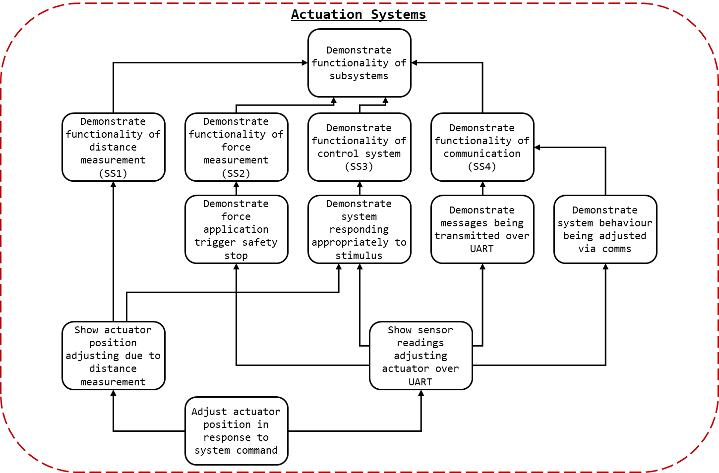

Figure 1: SS5 Breakdown

As detailed in Figure 1: SS5 Breakdown to demonstrate the functionality of the other major subsystems two representative action sets can be completed. The functionality of SS2,3, and 4 can be demonstrated by showing that force sensors readings from one device can, over the communication system, can shut off the operation of an actuator when the external force exceeds the internal force. The functionality of SS1 and 3 can be shown by demonstrating that the position of an actuator can be controlled by position sensor readings.

The functionality of both these tests however, is dependent on the behaviour of an actuator as directed by the system. The reason for two tests, rather than a single integrated test was a consequence of servomotor lead time, as noted in kt.

## Background and Prior Art

### Servomotor

A servomotor is a linear or rotary actuator with a closed-loop control system used to manage its behaviour. Usually a motor will be paired with an encoder to provide feedback to the system. The specific of the implementation of servomotors vary, as does their ability to control position, velocity, and acceleration.

### Pulse Width Modulation (PWM)

Pulse-width modulation (PWM) is a modulation technique most commonly used to encode and control the power output of motors. PWM works by toggling the output signal to a load sufficiently quickly to approximate analogue behaviour. I.e. in a system where power cannot directly be controlled, PWM can be used to ensure that the output signal is high 50% of the time, effectively demanding 50% power to be supplied. As long as the switching frequency is so high as for the resultant waveform to be perceived as continuous the load will behave as if driven by a continuous supply.

For the control of servomotors PWM is often used to indicate the desired behaviour (indicating position, speed, etc…). The signal delivered to the servomotor will be held low and then toggled high for a duration. The duration of the high period, or pulse, in relation to a full cycle period is the duty cycle. The duty cycle indicates to the servo the desired behaviour, see kt.

## Approach and Execution

### Actuators

Due to the time constraints associated with creating SS5 and the goal of demonstrating SS1-4 (not creating a functional exoskeleton), rather than creating a servomotor a prefabricated servomotor was selected as the desired actuator for SS5.

As the lead time associated with most high precision servomotors was beyond the remainder of the project when SS5 was commissioned (in response to learning there would be no exoskeleton) the selection of servomotors available to the project was limited. As such, there were no servomotors available capable of actuating with the force sensor plate attached (the torque requirements were simply too high).

For demonstrating the efficacy of the position system, the strongest servomotor available (by torque) was selected. Greater torque would allow for greater control authority when accelerating, and as the mock exoskeleton (see kt) would be constructed from suboptimal materials greater control authority was a priority. Thus, the MG995 servomotor was selected, see figure kt.

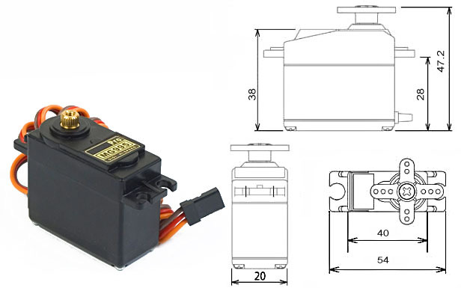

Figure 2: MG995 - High Speed Metal Gear Dual Ball Bearing Servo

The MG995 datasheet may be found in the attached documents as “MG995 - High Speed Metal Gear Dual Ball Bearing Servo.pdf”. The MG995 offered position-based control and 0.98 Nm (10 kgf cm) of torque (at 6V).

For demonstrating the efficacy of the force detection systems a continuous rotation servo was selected as it could stop when the external force on the suit exceeded the force internal, and could vary its speed depending on the force applied internally. Due to its availability the 900-00008 Continuous Rotation Servomotor was selected.

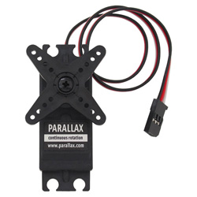

Figure 3: 900-00008 - Continuous Rotation Servo

The 900-00008 datasheet may be found in the attached documents as “900-00008 - Continuous Rotation Servo.pdf”.

To power and control the servomotors a PWM generated by the nucleo boards was used. As the PCBs designed, see kt, did not consider SS5 within scope at the time of fabrication, there were no dedicated headers for powering the servo. Later iterations remedied this by adding a dedicated servo header. For creating the configurations discussed in SS5 fly-wires were solder to the board, and the connections were heat shrunk, see kt. While this is suboptimal, it did allow for reliable and consistent control of the servomotors.

### Test A: Position detection

The first test, to demonstrate SS1 and SS3, would entail attaching the position detection system to a rod at the end of a servomotor and controlling the motor/rod position based on the position readings. Effectively a two-limb-segments/one-joint mock exoskeleton.

As seen in Figure 4: Test A Configuration, A fixed exoskeleton segment (A) is installed flush with a pilot limb segment (B) (e.g. thigh, bicep). At the joint and actuator (S) is used to rotate a free exoskeleton segment (C) flush and parallel to a limb segment of the pilot (D) (e.g. shin, forearm). The IR sensor frame (E) is mounted to the end of C and IR sensors (F) may determine the position of D.

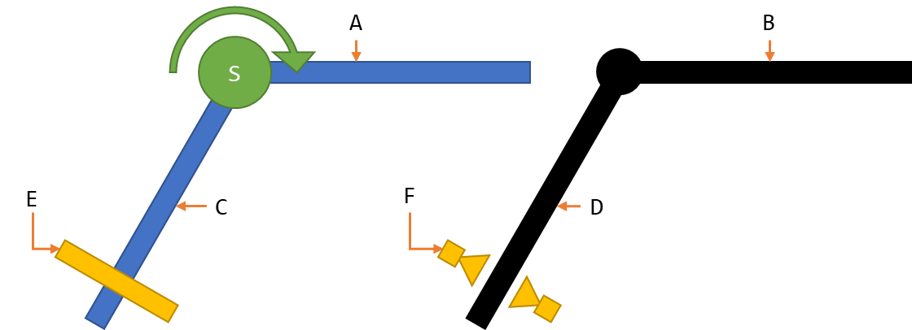

Figure 4: Test A Configuration

The MG995, discussed in kt, was used as the actuator for Test A. Aluminium beams ( x mm) kt were used for the exoskeleton segments. To minimise the weight of the perception system, the power supply for the servo, SS1, and SS3 where located on the upper segment. Additionally, the controls board was also located on the upper segment.

To mount the lower segment to the servomotor, cable ties were used to attach the segment to a servo horn. A bolt hole placed in the segment was then used to screw the servo horn, servomotor, and segment together, see kt.

### Test B: Force detection

The second test, to demonstrate SS2, SS3, and SS4, would entail connecting two boards via CAT 5e cables. As seen in Figure 5: Test B Configuration, one board (B) would send force measurements from SS2 (A) over the SS4 (C) and the other (D) would control an actuator (S) based on the received values.

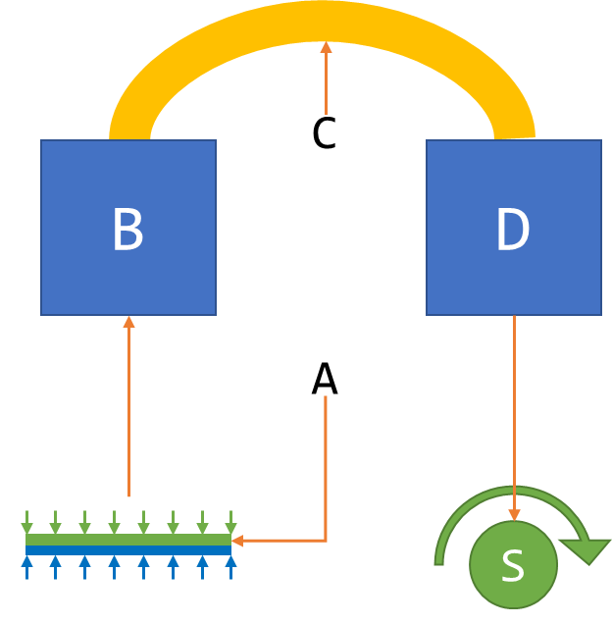

Figure 5: Test B Configuration

A single short aluminium beam ( x mm) kt was used as a platform for the test. Both boards were mounted to the beam. A CAT 5e cable was used to connect the two boards together.

### PWM Control

To control the servomotors PWM control was required.

For details relating to the microcontroller selection see section (kt).

A single PWM output channel was implemented in C for the STM32 Nucleo boards. Much of the peripheral initialisation was completed used STM32CubeMX. The configuration file used can be found in kt. The configuration of the PWM, including GPIO used, can be found in Table 1: PWM Configuration.

Table 1: PWM Configuration

|  |  |
| --- | --- |
| Parameter | Value |
| STM32F303k8 Pin | Port B Pin 4 |
| Nucleo Connector Pin | D12 |
| Timer | 3 |
| Channel | 1 |
| Prescaler (PSC - 16 bits value) | 72 |
| Counter Mode | Up |
| Counter Period (AutoReload Register - 16 bits value ) | 100 |
| Internal Clock Division (CKD) | No Division |
| Auto-reload preload | Disabled |
| PWM Generation Channel 1 Mode | PWM Mode 1 |

Once the PWM was initialised, the following methods was required for control:

* Start the PWM (HAL_TIM_PWM_Start(&htim3, TIM_CHANNEL_1))
* Determine Duty Cycle (volatile int DC;)
* Updated desired pulse width (set_pulse_width(void))
* Set the new pulse width & duty cycle, (__HAL_TIM_SET_COMPARE(&htim3, TIM_CHANNEL_1, pulse_width);

This could be used to control behaviour of the motors given the configuration, see Table 2: Motor PWM Requirements.

Table 2: Motor PWM Requirements

|  |  |
| --- | --- |
| Test A (MG995) |  |
| Cycle Period | 20 ms (50 Hz) |
| Min Pulse (-60 Deg) | 0.7 ms |
| Max Pulse (+60 Deg) | 2.5 ms |
| Idle Pulse (0 Deg) | 1.5 ms |
|  |  |
| Test B (900-00008) |  |
| Cycle Period | 20 ms (50 Hz) |
| Min Pulse (-50 rpm) | 1.3 ms |
| Max Pulse (+50 rpm) | 1.7 ms |
| Idle Pulse (0 rpm) | 1.5 ms |

## Results and Discussion

This section will detail the performance of the actuators selected and their interface with the supersystems. For discussion relating to the systems performance in Test A and Test B see section kt.

To summarise the results of SS5, it works but its ugly. We begin with the ugly.

The attachment mechanism for mounting associated with the servomotors depended on cable ties. While cable ties are perfectly adequate for cable management, and function well as a stand in for hose clamps at small diameters, they are not a robust or rigid method of fasting motors in place. In further iterations of the system it is strongly recommended that dedicated mounts for the servomotors be commissioned.

The exoskeleton segments, comprised of aluminium, were heavy and flexible. In Test A, a finger’s touch could cause the lower exoskeleton segment to wobble and flex. The system when tested would oscillate if accelerated too quickly, confusing the perception systems. This effectively capped the accuracy of the perception system and the speeds (and response times) at which stability could be attained.

Motor selection should not be determined by lead time. Instead actuators should be selected based their requirements. Originally the 900-00008 was to be used for Test A, but upon preliminary testing it was found that it lacked the torque to lift the lower exoskeleton segment beyond 30 degrees.

Neither servomotor allowed for control via torque or acceleration, the control variable used in SS3. Instead position and velocity were controlled. However, they could not be measured so the acceleration could not be indirectly controlled. The servomotors had their own internal control mechanisms, which had to be compensated for. Finally, the resolution of the MG995 was so low as to be visually perceptible. For all further iteration of the system it is strongly suggested that the actuators be reengineered.

Soldering loose cables to the through holes of a PCB header to control a system’s actuators is… not best practice. While later iterations of the PCB included dedicate servo headers, the PCBs used for demonstration featured fly-wires.

The battery system used for SS5 was functional but ramshackle. An 8-battery receptacle was modified to fit 4 batteries to power the 6V MG995. This should be replaced with a 4-battery receptacle.

Preferential to the improvements discussed SS5 should be make redundant. ***A functioning actuation and structural system would eliminate the need for SS5 entirely***.

Areas of possible improvement considered, SS5 as a whole worked, and performed as desired.

Analysis via logic analyser indicated that the PWM generation worked correctly in all circumstances. The PWM implemented worked correctly in all circumstances it was tested. The code developed was effective and functional.

The motors when testing in isolation or in Test A and Test B performed as instructed. While the response time of the MG995 was slower than preferred, it was adequate to demonstrate the functionality of perception systems.

# Bibliography

Agarwal, A. (2005). *Foundations of analog & digital electronic circuits* (1 ed.). Massachusetts: Massachusetts Institute of Technology. Retrieved June 1, 2018, from https://www.google.com/url?sa=t&rct=j&q=&esrc=s&source=web&cd=1&ved=0ahUKEwiBu7yQl7LbAhUEoZQKHfYlBzkQFggpMAA&url=http%3A%2F%2Fsiva.bgk.uni-obuda.hu%2Fjegyzetek%2FMechatronikai_alapismeretek%2FEnglish_Mechatr%2FElectr_Eng-1%2FLiterature%2FFoundations%2520o

American Technologies Network Corporation. (2018, May 30). *How Does Night Vision Work*. Retrieved from atncorp.com: https://www.atncorp.com/hownightvisionworks

Arrow. (2018). *Magnetoresistive Sensor.* Retrieved May 30, 2018, from arrow.com: https://www.arrow.com/en/categories/sensors/magnetoresistive-sensors

Axe, D. (2012, May 23). *Combat Exoskeleton Marches Toward Afghanistan Deployment*. Retrieved May 30, 2018, from Wired: https://www.wired.com/2012/05/combat-exoskeleton-afghanistan/

Bulgrin, M. (2017, May 11). *The History of the Hose Clamp.* Retrieved from normagroup.com: https://blog.normagroup.com/en/the-history-of-the-hose-clamp/

Bunnings. (2018, May 31). *Kinetic 21 - 44mm 304 Stainless Steel Hose Clamp.* Retrieved May 31, 2018, from Bunnings.com: https://www.bunnings.com.au/kinetic-21-44mm-304-stainless-steel-hose-clamp_p4920194

Charara, S. (2015, July 9). *This robotic exoskeleton helps paralysed patients to walk and it's getting smarter*. Retrieved August 23, 2017, from Wearable: https://www.wareable.com/wearable-tech/exoskeleton-paralysed-patients-ekso-bionics-gt-sarah-thomas

Computer Cable Store. (2018, May 31). *11 7/8 Inch Black Standard Nylon Cable Tie - 100 Pack.* Retrieved May 31, 2018, from computercablestore.com: https://www.computercablestore.com/11-78-inch-black-standard-nylon-cable-tie-100-pack

Cornwall, W. (2015, October 15). *Feature: Can we build an ‘Iron Man’ suit that gives soldiers a robotic boost?* Retrieved August 20, 2017, from sciencemag.org: http://www.sciencemag.org/news/2015/10/feature-can-we-build-iron-man-suit-gives-soldiers-robotic-boost

Cracknell, A. P., & Hayes, L. (2007). *Introduction to Remote Sensing* (2 ed.). London: Taylor and Francis. Retrieved May 30, 2018

Cutnell, J. D., & Johnson, K. W. (1998). *Physics* (4th ed.). New York: Wiley.

Cyberdyne. (2015, August 1). *CYBERDYNE Inc. has begun seeking approval from the U. S. Food and Drug Administration (FDA)*. Retrieved August 23, 2017, from cyberdyne.jp: https://www.cyberdyne.jp/english/company/PressReleases_detail.html?id=1075

Cyberdyne. (2016). *What’s HAL?* Retrieved August 19, 2017, from cyberdyne.jp: https://www.cyberdyne.jp/english/products/HAL/

Cybernetic Zoo. (2010, October 14). *1890 – Assisted-walking Device – Nicholas Yagn (Russian)*. Retrieved May 30, 2018, from Cyberneticzoo.com: http://cyberneticzoo.com/tag/nicholas-yagn/

Cybernetic Zoo. (2010, April 10). *1965-71 – G.E. Hardiman I Exoskeleton – Ralph Mosher (American)*. Retrieved May 30, 2018, from cyberneticzoo.com: http://cyberneticzoo.com/man-amplifiers/1966-69-g-e-hardiman-i-ralph-mosher-american/

Dawkins, P. (2018). *Differential Equations - Notes - Laplace’s Equation*. Retrieved June 3, 2018, from Paul's Online Math Notes: http://tutorial.math.lamar.edu/Classes/DE/LaplacesEqn.aspx

Dunietz, J. (2017, July 27). *Robotic Exoskeleton Adapts While It’s Worn*. Retrieved August 20, 2017, from scientificamerican.com: https://www.scientificamerican.com/article/robotic-exoskeleton-ldquo-evolves-rdquo-while-its-worn/

Future Electronics. (2018, May 30). *What is Optoelectronics?* Retrieved from Future Electronics: http://www.futureelectronics.com/en/optoelectronics/infrared-receivers.aspx

Garbett, I. (2001, Janurary 1). *Light attenuation and exponential laws*. Retrieved May 30, 2018, from plus.maths.org: https://plus.maths.org/content/light-attenuation-and-exponential-laws

Golnaraghi, F., & Kuo, B. C. (2010). *Automatic Control Systems* (9 ed.). Hoboken: John Wiley & Sons, Inc. Retrieved June 4, 2018

Gross, K. (2018, Feburary 19). *Ultrasonic Sensors: Advantages and Limitations*. Retrieved May 30, 2018, from MaxBotix: https://www.maxbotix.com/articles/advantages-limitations-ultrasonic-sensors.htm/

Jackson, R., Green, K. R., & Eisenbeis, R. (2017). *Achieve greater precision, reliability with integrated magnetic sensing technology.* Retrieved May 30, 2018, from ti.com: http://www.ti.com/general/docs/lit/getliterature.tsp?baseLiteratureNumber=sszy030&fileType=pdf

Karlin, S. (2011, July 29). *Raytheon Sarcos’s Exoskeleton Nears Production*. Retrieved August 11, 2017, from spectrum.ieee.org: http://spectrum.ieee.org/at-work/innovation/raytheon-sarcoss-exoskeleton-nears-produc

Keller, M. (2016, August 25). *Exoskeleton - Do You Even Lift, Bro? Hardiman Was GE’s Muscular Take On The Human-Machine Interface*. (General Electric) Retrieved May 30, 2018, from GE Reports: https://www.ge.com/reports/do-you-even-lift-bro-hardiman-and-the-human-machine-interface/

Keyence Corporation. (2018). *What is a Inductive Proximity Sensor?* Retrieved May 30, 2018, from keyence.com: https://www.keyence.com/ss/products/sensor/sensorbasics/proximity/info/

Khatib, O. (2008). Chapter 5 - Dynamics. In O. Khatib, *Introduction to Robotics* (pp. 125-150). Stanford: Stanford University.

Liew, S. C. (2018, May 30). *Electromagnetic Waves*. Retrieved from Centre for Remote Imaging, Sensing and Processing.: https://crisp.nus.edu.sg/~research/tutorial/em.htm

Lynch, D. K., & Livingston, W. C. (2001). *Color and Light in Nature* (2nd ed.). Cambridge, United Kingdom: Cambridge University Press. Retrieved May 30, 2018, from https://books.google.com.au/books?id=4Abp5FdhskAC&pg=PA231&redir_esc=y#v=onepage&q&f=false

Merriam-Webster Dictionary. (2018, May 18). *noise*. Retrieved May 30, 2018, from merriam-webster.com: https://www.merriam-webster.com/dictionary/noise

National Instruments. (2018). *PID Theory Explained.* Retrieved June 4, 2018, from NationalInstruments.com: http://www.ni.com/white-paper/3782/en/

Ogata, K. (2010). *Modern Control Engineering* (2 ed.). New Jersey, United States of America: Prentice Hall. Retrieved August 25, 2017

Otaga, K. (2004). *System Dynamics* (4 ed.). Upper Saddle River: Pearson. Retrieved June 4, 2018

Robomart. (2015, November 9). *Advantages and Disadvantages of ultrasonic distance sensor.* Retrieved May 30, 2018, from Robomart: http://roboticsensors.blogspot.com/2015/11/advantages-and-disadvantages-of.html

Siciliano, B., & Khatib, O. (2016). *Springer Handbook of Robotics* (2 ed.). (B. Siciliano, & O. Khatib, Eds.) Berlin: Springer Nature. doi:10.1007/978-3-319-32552-1

Texas Instruments Incorporated. (2017). *Hall effect sensors*. Retrieved May 30, 2018, from ti.com: http://www.ti.com/sensing-products/magnetic-sensors/hall-effect/overview.html

Thomas Publishing Company. (2018). *Capacitive Proximity Sensors*. Retrieved May 30, 2018, from Thomas: https://www.thomasnet.com/articles/instruments-controls/proximity-sensors

Vishay Semiconductors. (2017, February 8). TCRT5000 - Reflective Optical Sensor with Transistor Output.

Yagin, N. (1890, February 11). *United States of America Patent No. 440684.*

Yuhas, D. (2012, May 24). *Speedy Science: How Fast Can You React?* Retrieved from scientificamerican.com: https://www.scientificamerican.com/article/bring-science-home-reaction-time/

ZJIA. (2018, June 1). *Generic YZC-161B 50kg Body Scale Sensor Human Scale Weighing Load Cell Sensor (Pack of 4)* . Retrieved June 1, 2018, from Amazon.com: https://www.amazon.com/Generic-YZC-161B-Scale-Sensor-Weighing/dp/B00MTJ6WZ2